**LAB # 08**

**CSS stylesheets and Techniques**

## OBJECTIVE:

Using CSS style sheets and using Pseudo classes

### THEORY:

**HTML BLOCK ELEMENT**

A block-level element always starts on a new line and takes up the full width available (stretches out to the left and right as far as it can).

The <div> element is a block-level element.

**Examples:** <div>, <h1> - <h6>, <p>, <form>

**HTML INLINE ELEMENT**

An inline element does not start on a new line and only takes up as much width as necessary.

The <span> element is a block-level element.

**Examples:** <span>, <a>, <img>

**CSS**

There are three types of stylesheets:

1. Inline
2. External
3. Embedded/Internal

**Types of CSS**

1. **Inline**

* Inline style sheets allow you to add styles directly to an HTML element.
* Inline style sheets is a term that refers to style sheet information being applied to the current element.

<p style="color:red;font-size:18px">This is a paragraph!</p>

1. **Embedded/Internal style sheet**

* Embedded style sheets allow you to define styles for the whole HTML document in one place.
* Embedded style sheets refer to when you embed style sheet information into an HTML document using the [<style>](http://www.quackit.com/html_5/tags/html_style_tag.cfm) element. You do this by embedding the style sheet information within [<style></style>](http://www.quackit.com/html_5/tags/html_style_tag.cfm)tags in the head of your document.

1. **External Style sheet**

* Apply styles to a whole website by placing the CSS into an external stylesheet.
* An external style sheet is a separate file where you can declare all the styles that you want to use on your website. You then link to the external style sheet from all your HTML pages.
* This means you only need to set the styles for each element once. If you want to update the style of your website, you only need to do it in one place.

**Example of Internal Style Sheet**

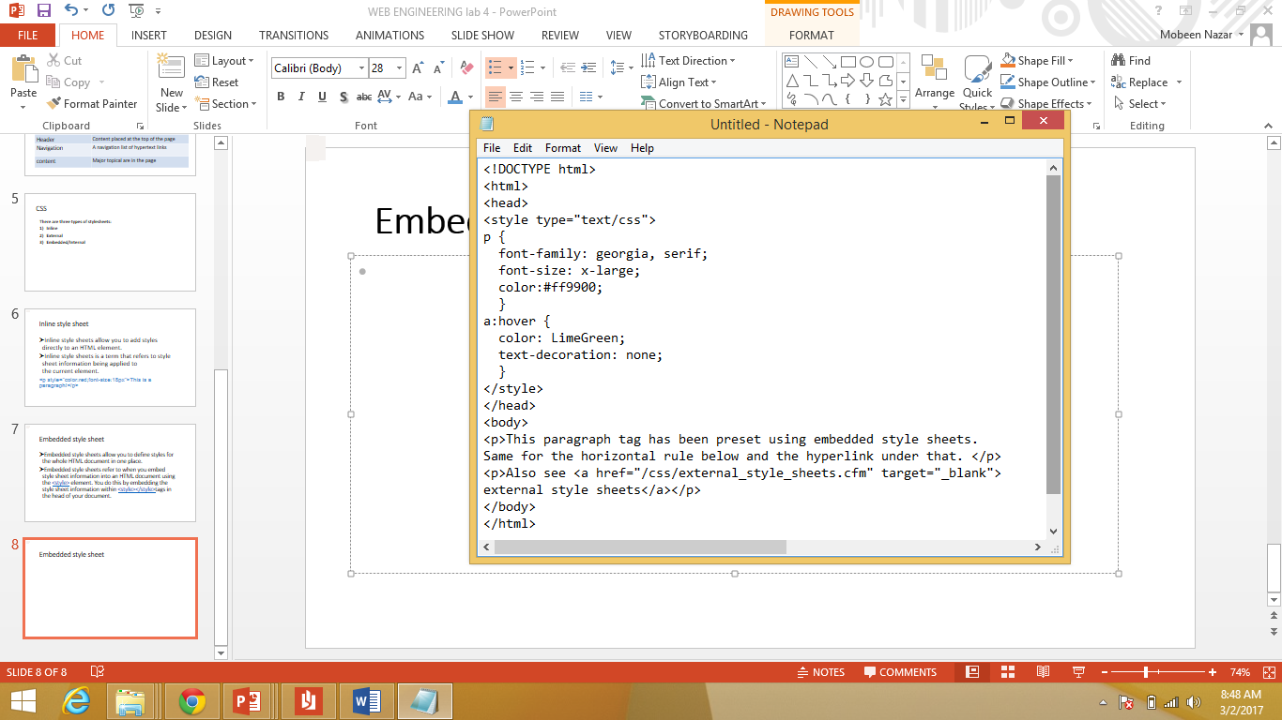

**Example of External Style Sheet**

Steps

1. Style.css
2. Index.html
3. Link css into html

<link rel="stylesheet" href="styles.css">

**Style.CSS**

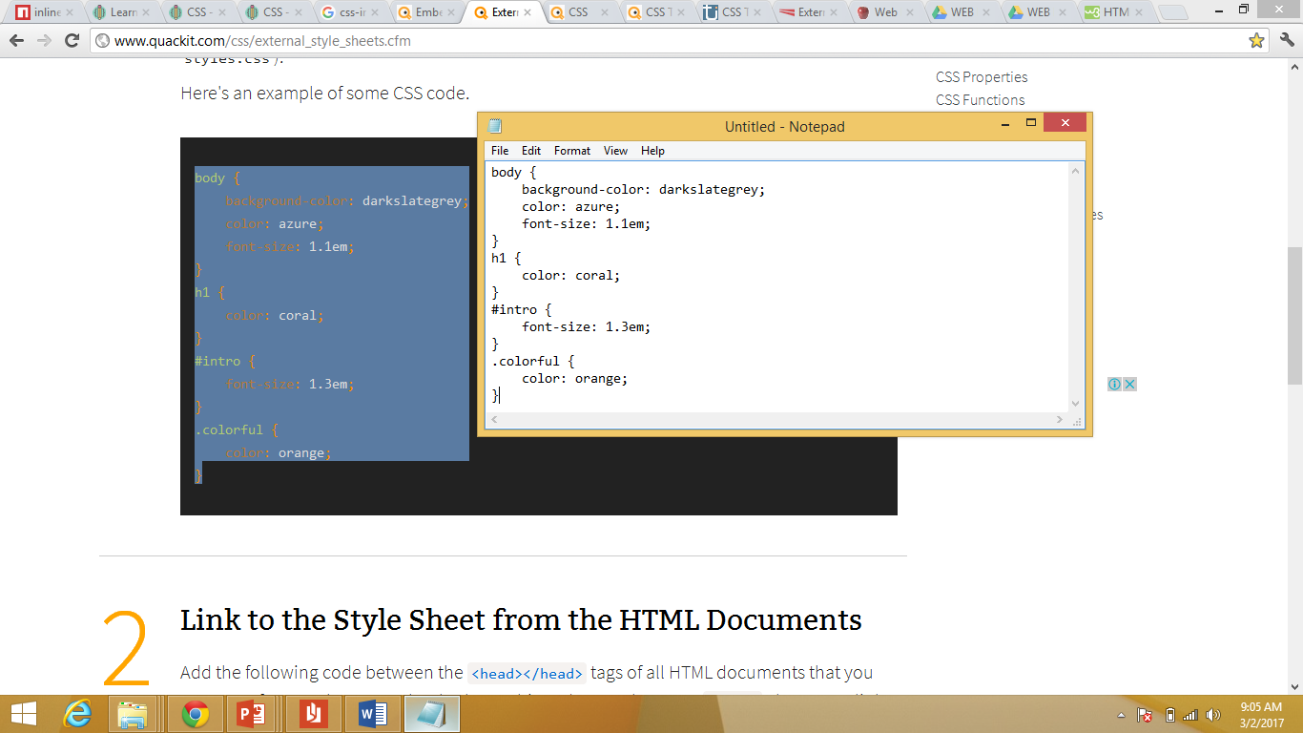

**Index.html**

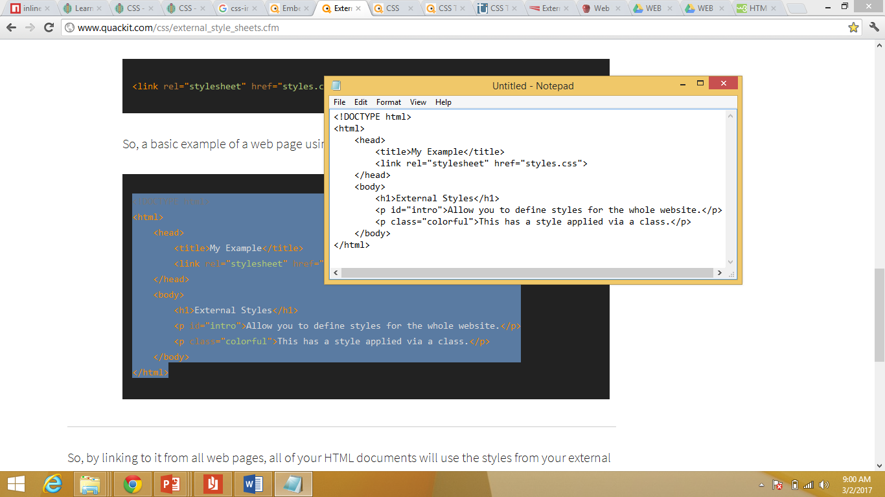

**CSS Pseudo-classes**

* A pseudo-class is used to define a special state of an element.

For example, it can be used to:

* Style an element when a user mouse over it
* Style visited and unvisited links differently
* Style an element when it gets focus

**Example: Anchor Pseudo Classes (Links Can be displayed in different ways)**

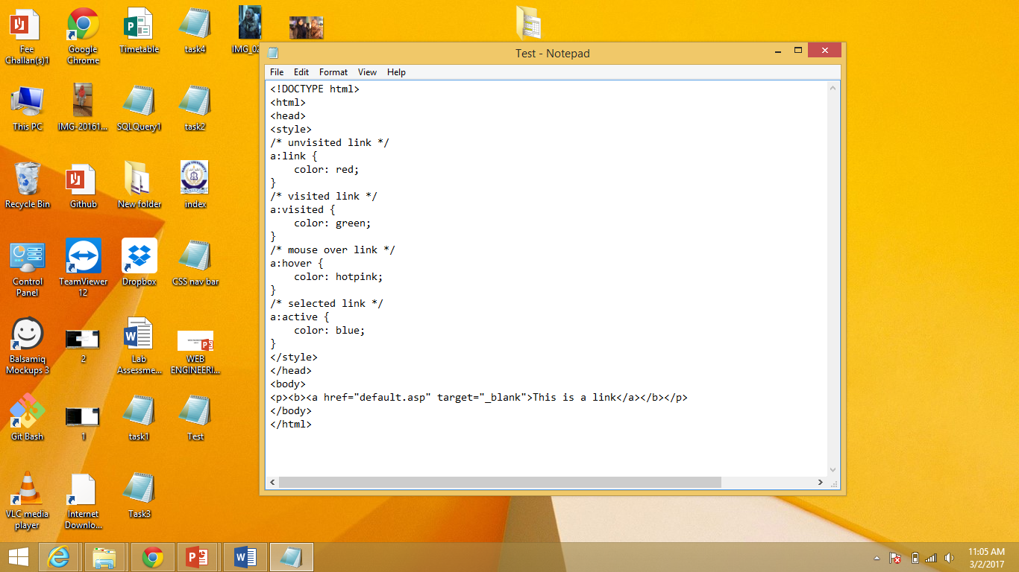

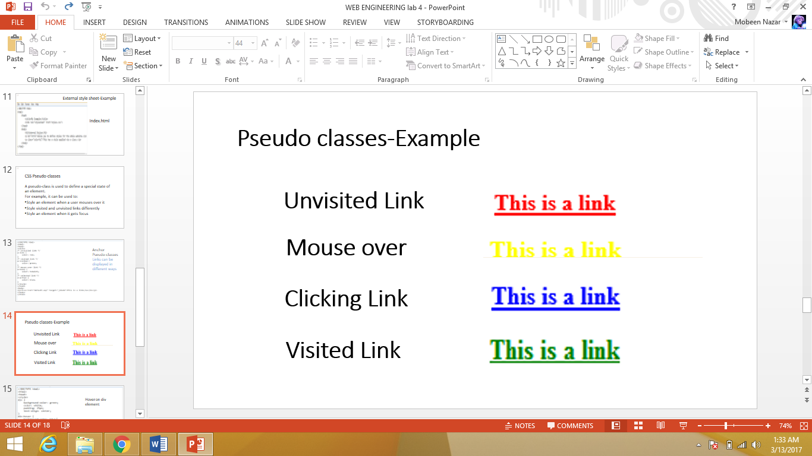**Output**

**Example: Hover on Div. Element**

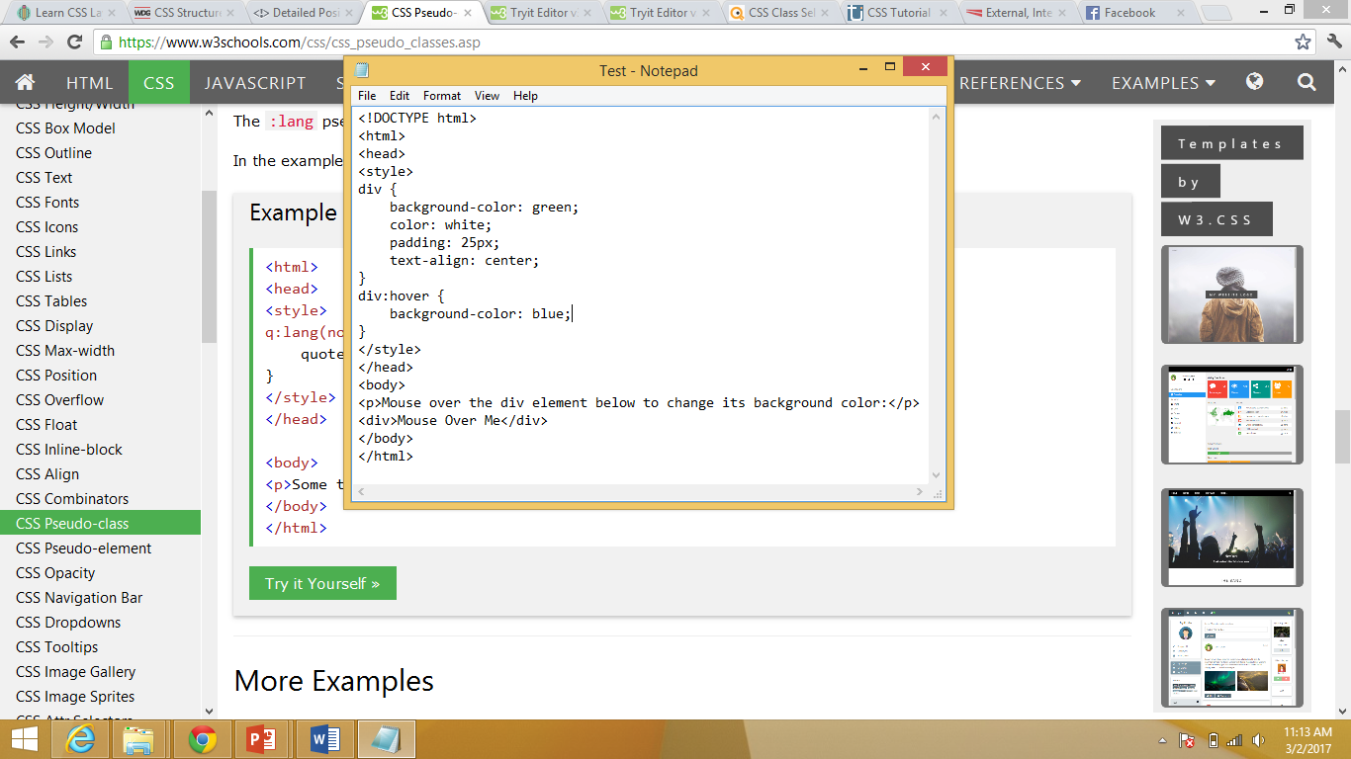

**Output:**

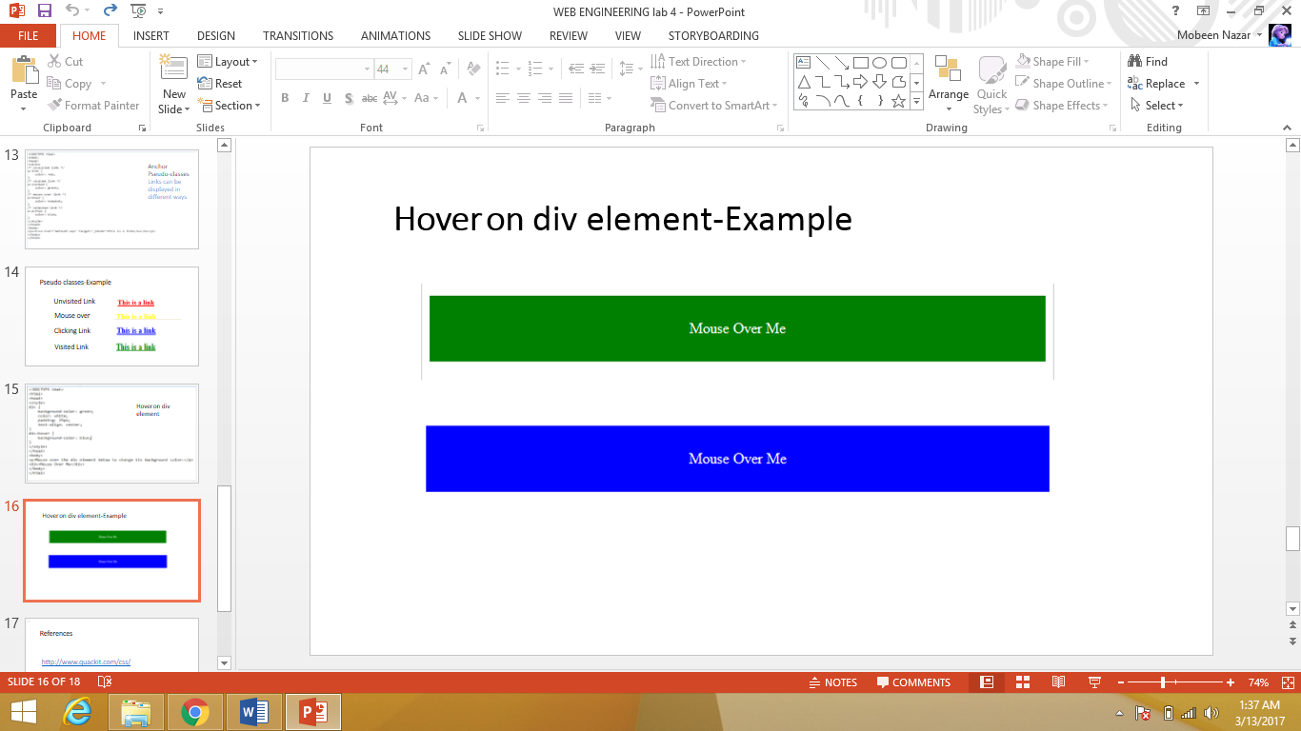

**CSS Horizontal Navigation Bar**

<!DOCTYPE html>

<html>

<head>

<style>

ul {

list-style-type: none;

margin: 0;

padding: 0;

overflow: hidden;

background-color: #333;

}

li {

float: left;

}

li a {

display: block;

color: white;

text-align: center;

padding: 14px 16px;

text-decoration: none;

}

li a:hover {

background-color: #111;

}

</style>

</head>

<body>

<ul>

<li><a class="active" href="#home">Home</a></li>

<li><a href="#news">News</a></li>

<li><a href="#contact">Contact</a></li>

<li><a href="#about">About</a></li>

</ul>

</body>

</html>

## **LAB TASKS**

* Design a webpage including html & CSS. Include all the things told in lab and the things included in assignment. The following navigation tabs must be added:

1. Home ( Give info about what your website is about)
2. Information (Include the detailed information related to the particular technology)
3. Gallery (Include images and Videos of technology)
4. About (Give the information about yourself)